CPDesktop Content Creation Concept

- Content Creation generates “PDB Report” (CSV file) defining Content relationship and attributes.
For example:

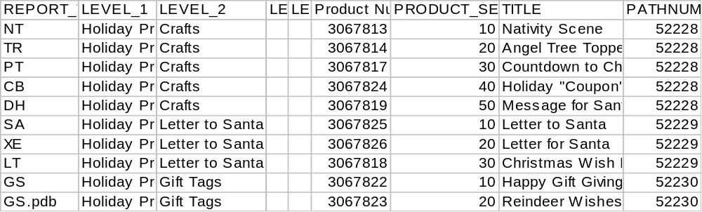

- Run BuildOfflineContent.js.
  - It will prompt for CSV file. V drive needs to be accessible.
  - Product files (ctp and thumbs) are downloaded from server, 'V:\\websitesimg\\american\\html\\product\\'.
The product number in csv file is also used to locate files.
  - It will organize downloaded files and data from CSV in folder corresponding to what App expects. For example, the “Pack” folder pictured below: example: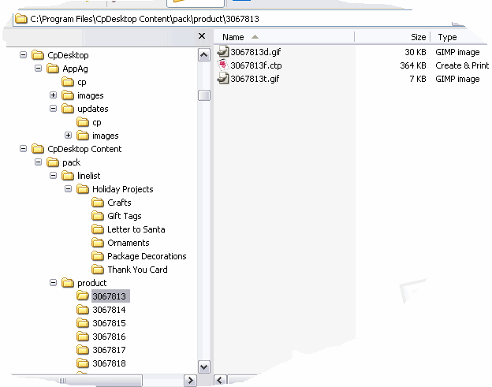

- When CpDesktop runs (or Hp Design Studio) it performs a checksum, a simple count of files under “pack”. It does this to determine whether or not to generate a new LineList.xml (Tree.xml for HP Design Studio).
  - Linelist.xml is generated when checksum stored in registry does not match.
  - Linelist.xml is input to LineList.xsl which renders the treeview for the UI.

